9. Art Bible

This provides a detailed description of the art style and art assets of the game “Food Fight”.

**9.1 Art Style**

The art style for the assets in the game will have a stylized cartoon appearance.

Bold colors will be used to easily distinguish the various characters, foods and backgrounds.

**9.2 Setting**

Each scene should have a backdrop image and a separate image for each tier of the NPC cover so that NPC’s can be placed behind them.

All artwork for the settings should be produced at iPad Retina display sizes and saved to the proper directory with the proper naming convention.

|  |  |  |  |
| --- | --- | --- | --- |
| **Device** | **Resolution** | **Directory** | **Filenames** |
| iPad | 2048 x 1536 | assets/scenes/**[scene]**/iPad | **[level]**_**[piece]**_x2.png |

9.2.1 Cafeteria

The cafeteria will be a large room with many table and chairs within it. The color palette will be cool with lots of blues and whites. The enemies will use the tables to hide behind during the game.

|  |  |
| --- | --- |
| **Description** | **Location** |
| Backdrop | assets/scenes/cafeteria/iPad/cafeteria_backdrop_x2.png |
| Cover Tier 1 | assets/scenes/cafeteria/iPad/cafeteria_cover_tier1_x2.png |

9.2.2 Study Hall

The Study Hall level will be similar to the cafeteria level, but smaller. The room will be filled with desks and have a similar color palette as the cafeteria, with many cool colors. The enemies will use desks to hide behind during the level.

|  |  |
| --- | --- |
| **Description** | **Location** |
| Backdrop | assets/scenes/study_hall/iPad/study_hall_backdrop_x2.png |
| Cover Tier 1 | assets/scenes/study_hall/iPad/study_hall_cover_tier1_x2.png |

9.2.3 Prom

The prom will be situated in a large party room. Tables and chairs will fill the room as well as a large dance floor. The color palette for the room will also be cool colors, mainly greens and whites. The enemies will use tables to hide behind during the level.

|  |  |
| --- | --- |
| **Description** | **Location** |
| Backdrop | assets/scenes/prom/iPad/prom_backdrop_x2.png |
| Cover Tier 1 | assets/scenes/prom/iPad/prom_cover_tier1_x2.png |

**9.3 Cutscenes**

Each cutscene will consist of three different still frames to set the story and prepare the player for the gameplay following the cutscene.

9.3.1 Cafeteria

The first cutscene takes place inside of the school cafeteria. The cutscene will begin with the main character “Snack” walking into the school cafeteria. As he makes his way into the cafeteria, he is hit with a slice of pizza. Snack looks across the cafeteria and see’s “Pizza Face”, who has been bullying him all year. Snack finally decides to stand up for himself and throws the slice of pizza back at him and the cutscene ends, which starts the gameplay.

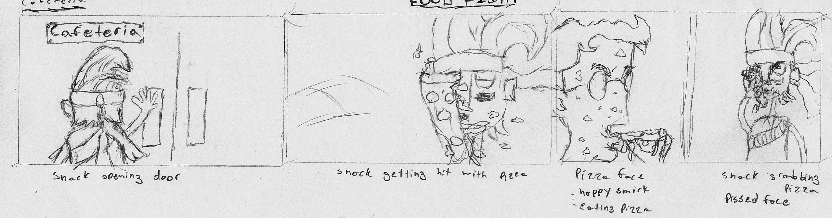

|  |  |
| --- | --- |
| **Description** | **Location** |
| Cafeteria | assets/cutscenes/ |

9.3.2 Study Hall

The second cutscene takes place inside of a study hall. The cutscene will begin with the main character “Snack” sitting in study hall and studying his notes. Snack then feels something hit him in the back of the head and he turns around to see who threw something at him. He see’s “Rad Tish” , who is another bully who’s been bullying Snack all year. She throws her sandwich at Snack but he grabs it before it hits him and smiles. The cutscene ends, which starts the gameplay.

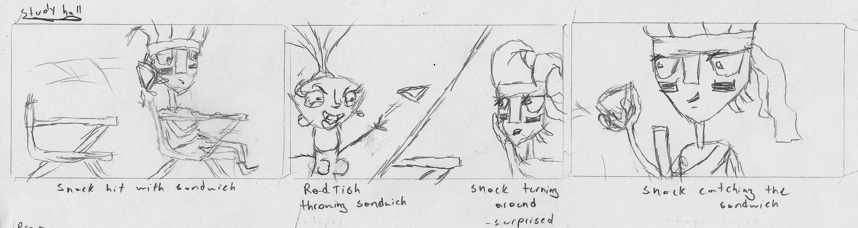

|  |  |
| --- | --- |
| **Description** | **Location** |
| Study Hall | assets/cutscenes/ |

9.3.3 Prom

The third cutscene takes place at the school prom. The cutscene will begin with the main character “Snack” at prom, leaning against a wall by himself and drinking fruit punch. As he’s about to take a sip from the cup, a piece of fried chicken hits his cup and knocks it out of his hands. Snack looks to the left across the room and see’s “Big” Mac, who is another bully who’s been bullying Snack all year. Frustrated, Snack decides he needs to end this once and for all. He grabs a handful of cake and the cutscene ends, which starts the gameplay.

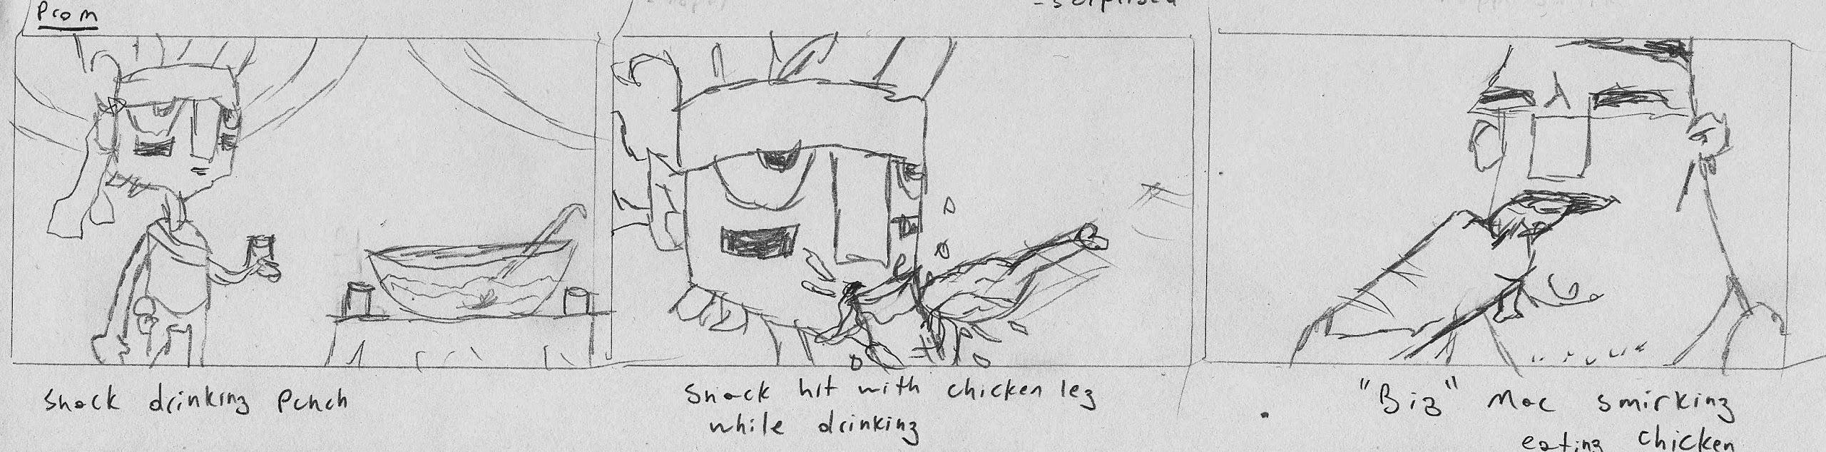

|  |  |
| --- | --- |
| **Description** | **Location** |
| Prom | assets/cutscenes/ |

**9.4 UI**

The UI for food fight should be playful yet still reflect the styles set forth by the character and environment designs. The color scheme and typefaces should remain consistent throughout the game. Much of the menu interface on the front end should remain modular and styled similarly.

Window modules and buttons should remain 9-slice editable so that they can be used with the unity GUI system.

9.4.1 Menus

9.4.1.1 Splash Screen

9.4.1.2 Standard Menu ( Main Menu, Options, Pause )

9.4.1.3 Help Menu

9.4.1.4 Level Select

9.4.1.5 Load Out

|  |  |
| --- | --- |
| **Description** | **Location** |
| Short description | assets/ui/menu/ |

9.4.2 H.U.D.

The hud will display important information during gameplay.Persistent sections of the hud will appear in the corners of the screen, while pop up messages will appear in the center of the screen but will only remain on screen for a few seconds. Such messages will include hit indicators and notifications when power up’s become active.

All hud elements will follow the same styling guidelines set forth for the Menus. Each element will be broken apart into their own module so that they can scale independently of one another. Text floating of the gameplay ( Flash messages and Points Collected ) should have a thick border around it to help it stand out from the background.

9.4.2.1 Timer

This piece will be located in the upper left corner. This will display the time left in the current game in seconds. Below the time there will be a pause button that will open the pause menu and trigger a pause state in the game.

9.4.2.2 Score

This piece will be located in the upper right corner. It will display the current score, active power-ups, and flash points when their collected. The active power-ups will display under the current score slightly bleeding out of the bubble. Collected points will be flashed for a few seconds below the power-ups color coordinated to the amount of points they collect.

|  |  |
| --- | --- |
| **Points** | **RGB** |
| < 2,500 | 255, 255, 255 |
| 2,501 - 5,000 | 219, 186, 21 |
| 5,000 - 10,000 | 90, 114, 152 |
| 10,000+ | 90, 120, 68 |

9.4.2.3 Inventory

This piece will appear in the bottom right corner. It will display the next food item the player will receive to throw. It will also display the number of food items that the player has left to throw during the round. The next food item will appear as an a sprite over top of the actual module and will “pop” in and out as new items are loaded. The number of food items left will be displayed to the left of the food icon.

9.4.2.4 Flash Messages

Flash messages will be displayed slightly above center screen. They will only appear for 1-2 seconds at a time and will float upwardly and fade out. These messages will be used to indicate hits, power-up activations and display warnings every 5 seconds after the last 20 seconds along with a countdown at 5 seconds. It will also display success messages when the target points have been reached.

9.4.2.5 Pause Menu

The pause menu will stop gameplay and hide the Inventory hud element when active. The actual menu will appear center screen and display four buttons, “Play”, “Options”, “Help”, “Quit”. The styling and appearance will remain the same as previous menus. Options and Help will appear in the same module window whilst the Quit option will prompt the user to confirm their action.

*(fig. 9.4.2a) Wireframe mockup of main H.U.D. Elements*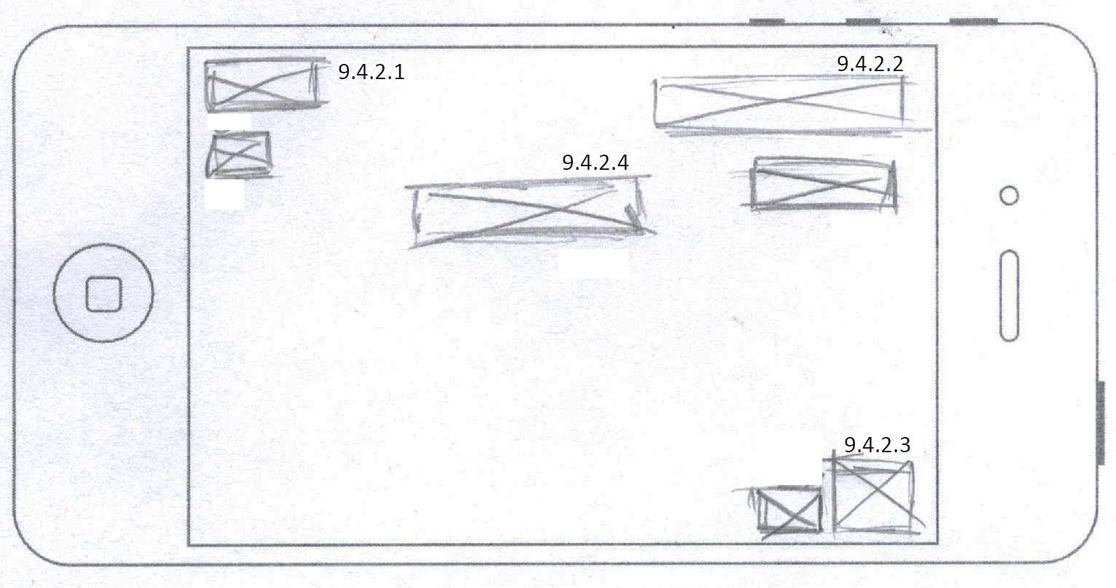

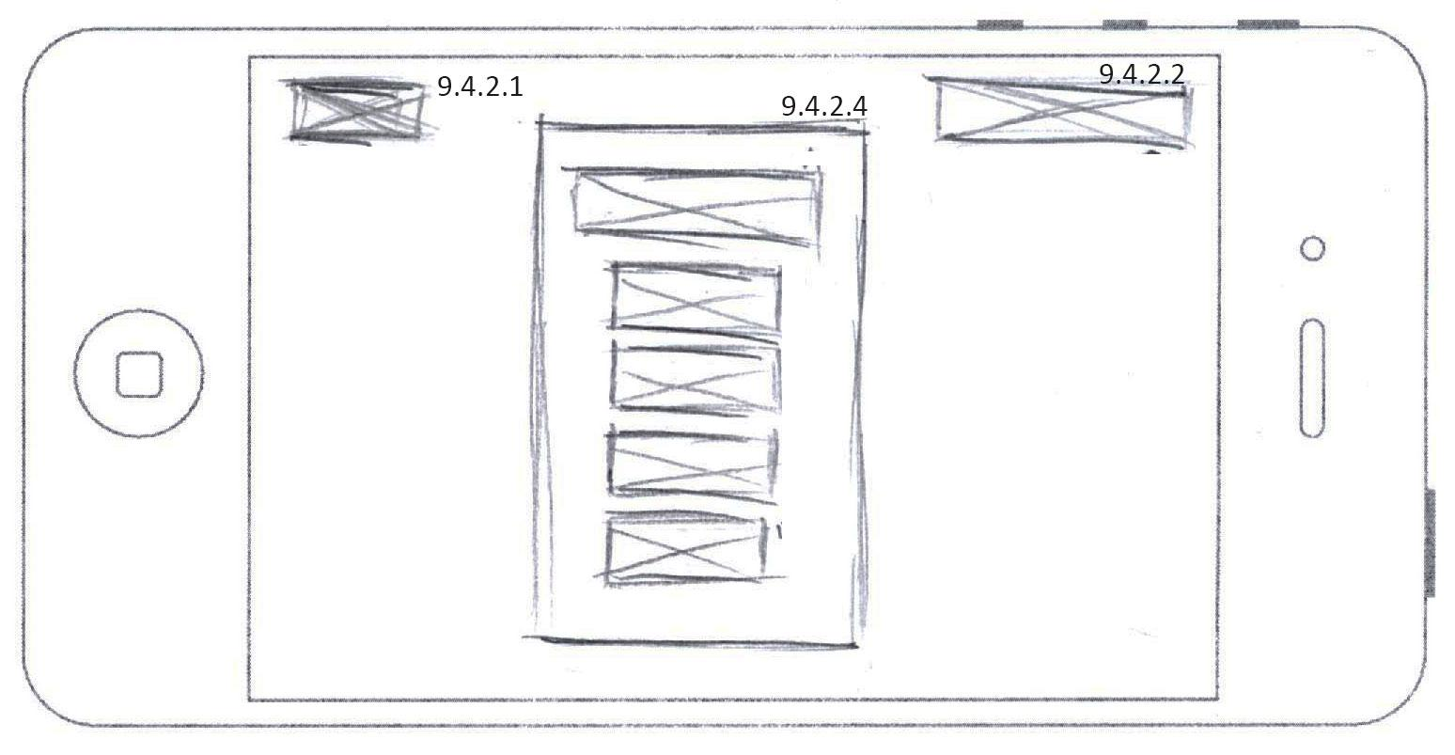

*(fig. 9.4.2a) Wireframe mockup of pause state*

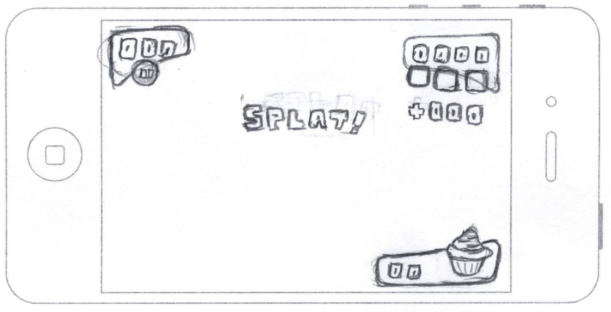

*(fig. 9.4.2c) Early concept for hud elements*

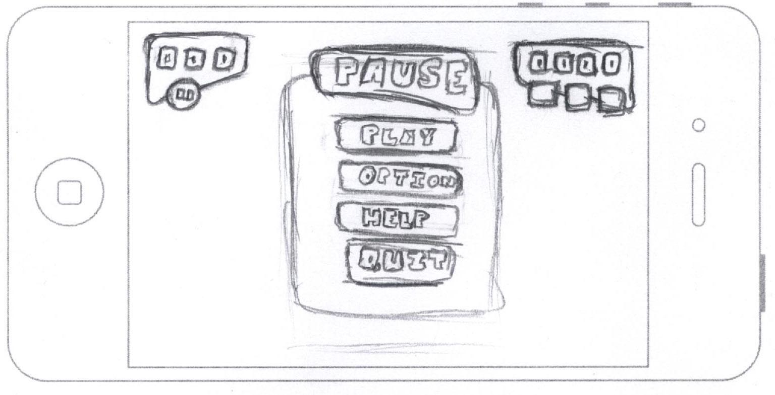

*(fig. 9.4.2a) Early concept for H.U.D. during paused state.*

|  |  |
| --- | --- |
| **Description** | **Location** |
| Short description | assets/ui/hud/ |

**9.5 Characters**

9.5.1 Snack

Snack isn’t your average joe. He’s essentially shy but has the heart of a warrior. His outward appearance reflects his fighting nature. A bandana wrapped around his head, carrot amo piled onto his chest, and two tomatoes strapped to his side. Snack is always prepared for a food fight.

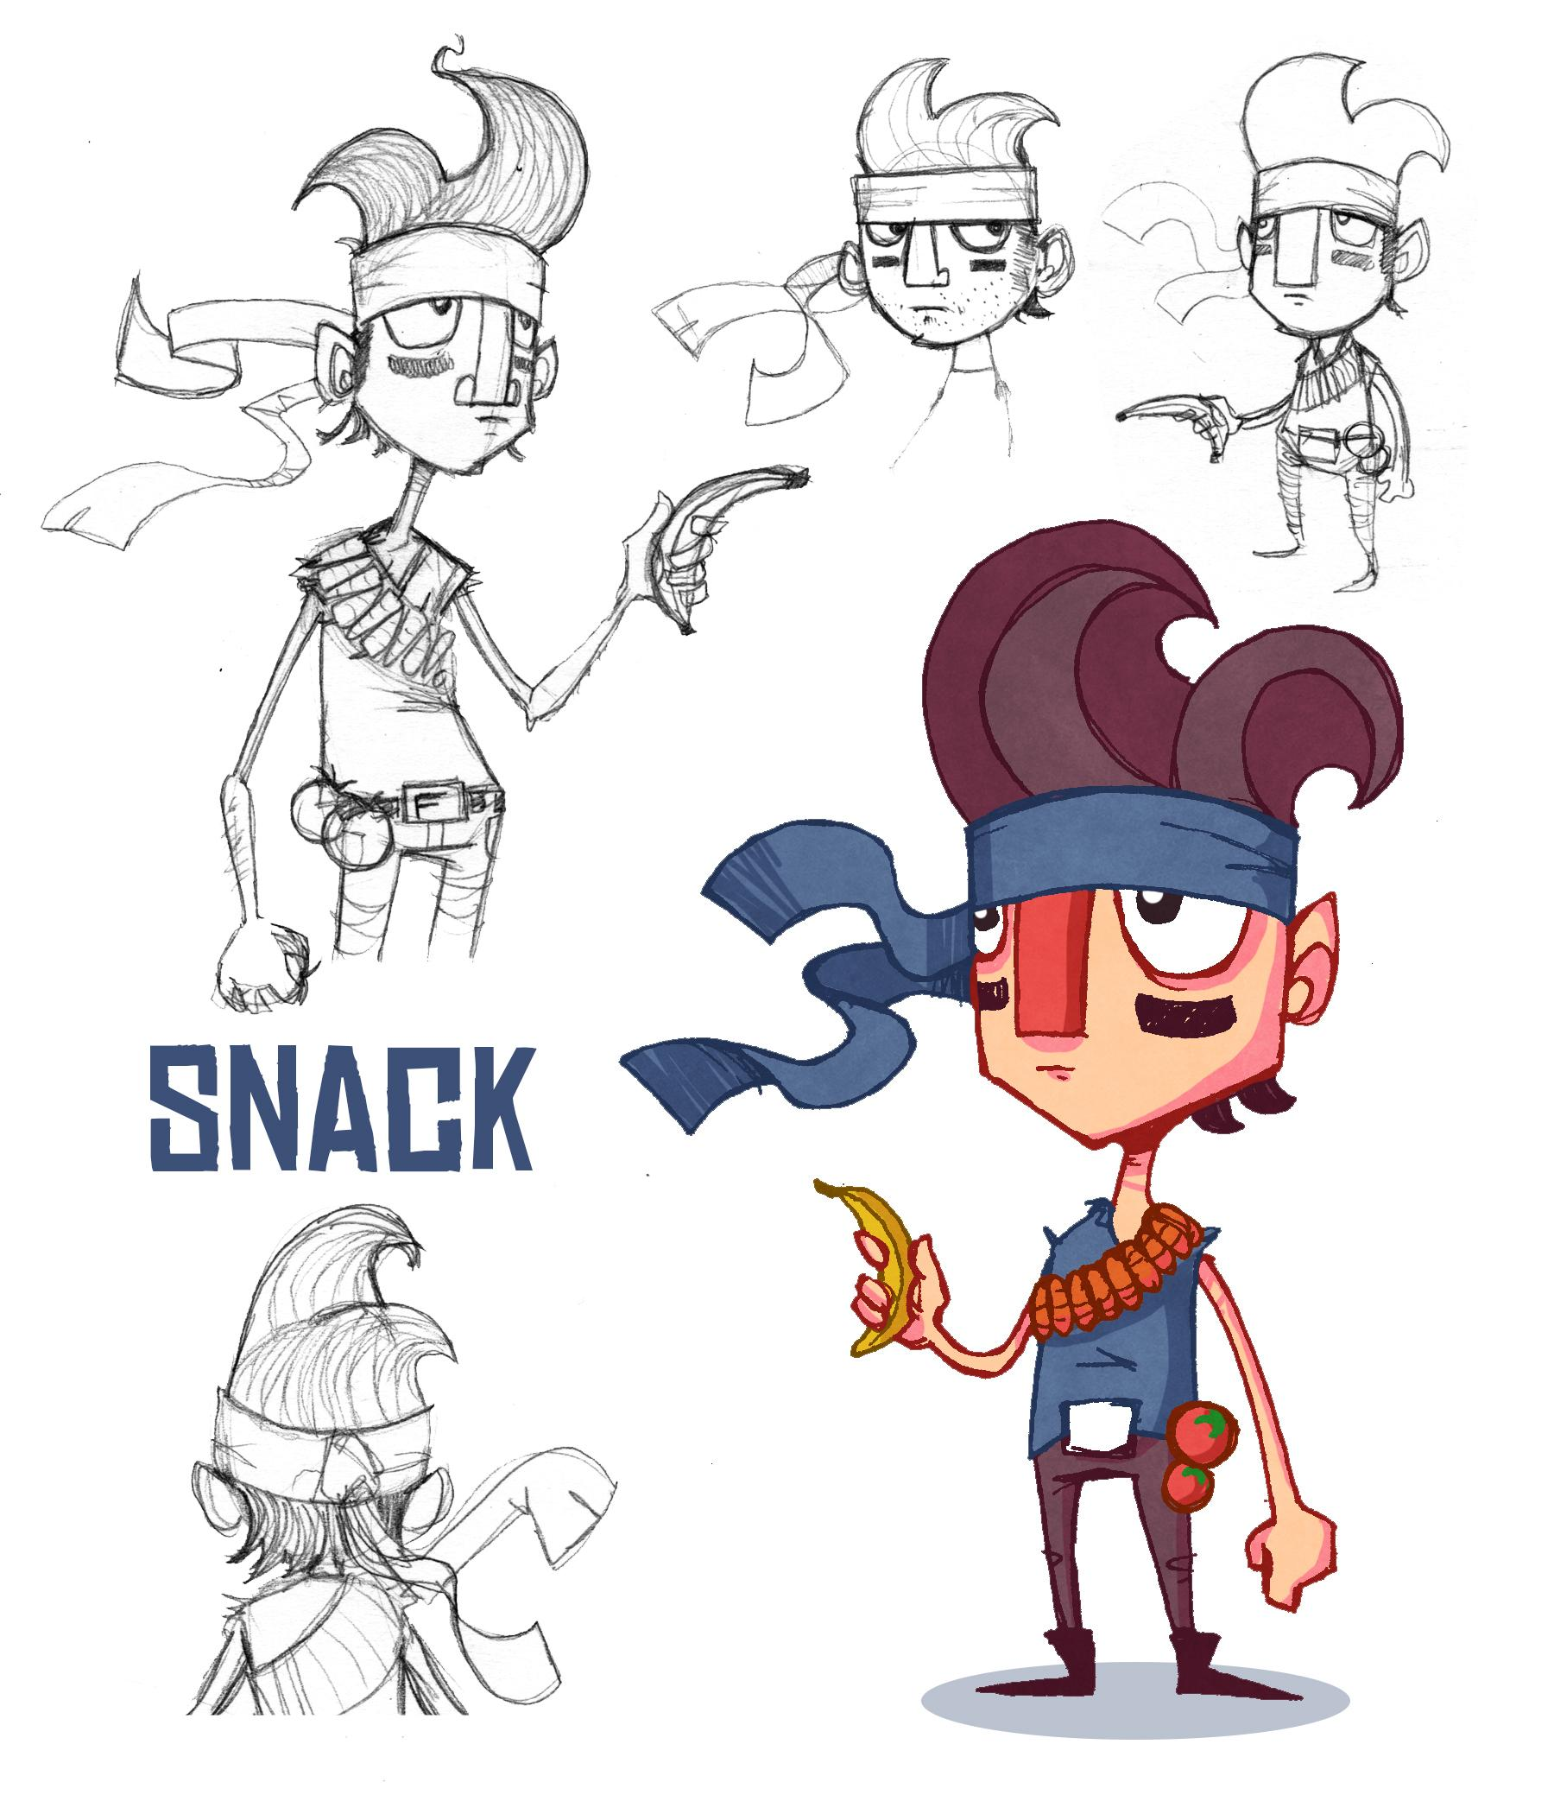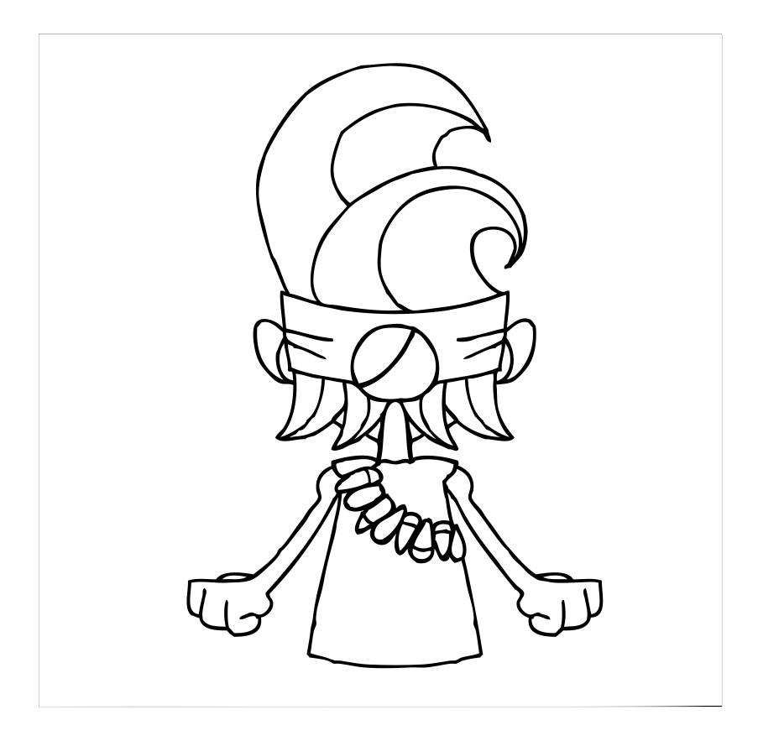

|  |  |
| --- | --- |
| **Description** | **Location** |
| Snack | assets/characters/ |

9.5.2 “Big” Mac

Mac is your typical bully: brawn over brain. But where he lacks smarts he makes up for in his massive size. Hence the reason he was dubbed the name Big Mac. It doesn’t help that he wears a tank top resembling a cheeseburger. Using his massive arms Big Mac can be sure to launch some pretty deadly strikes.

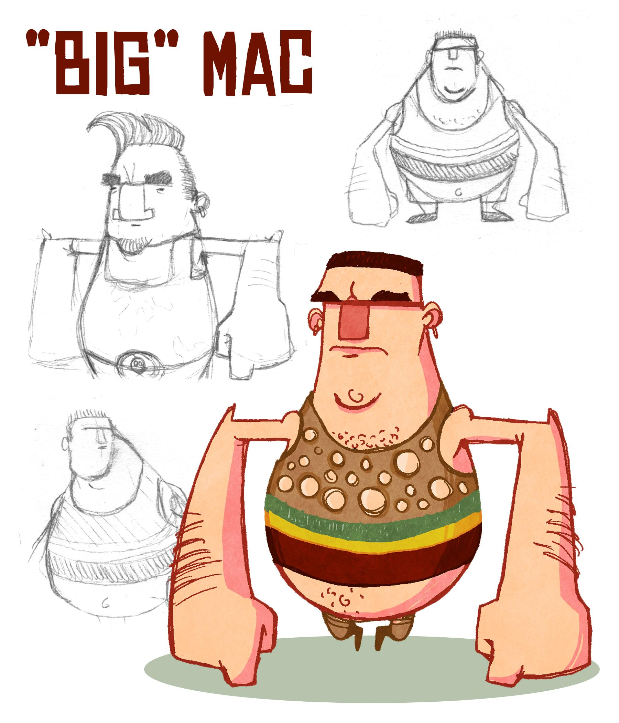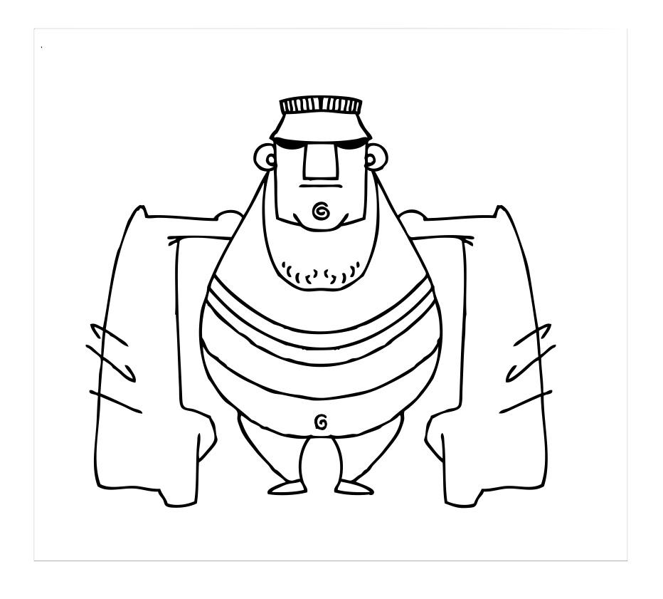

|  |  |
| --- | --- |
| **Description** | **Location** |
| Big Mac | assets/characters/ |

9.5.3 Pizza Face

Pizza Face has been made fun of for so long for his extreme acne that everyone's forgotten his real name. He’s a frail, small, cowering nerd with one thing on his mind: to get even. Since his name is pizza face his appearance and color palette resemble that of pizza. Reds and yellows and lots of “pepperoni” features.

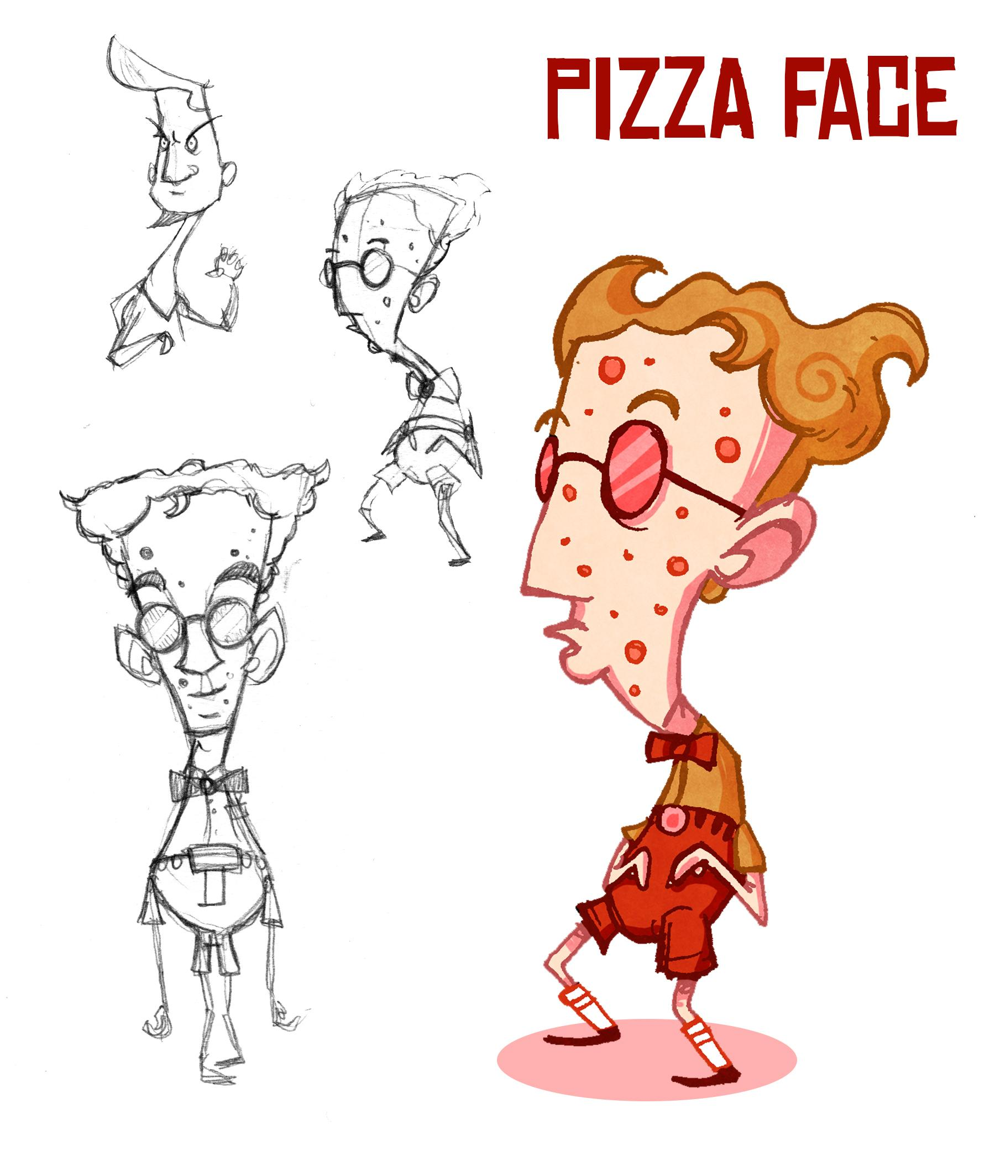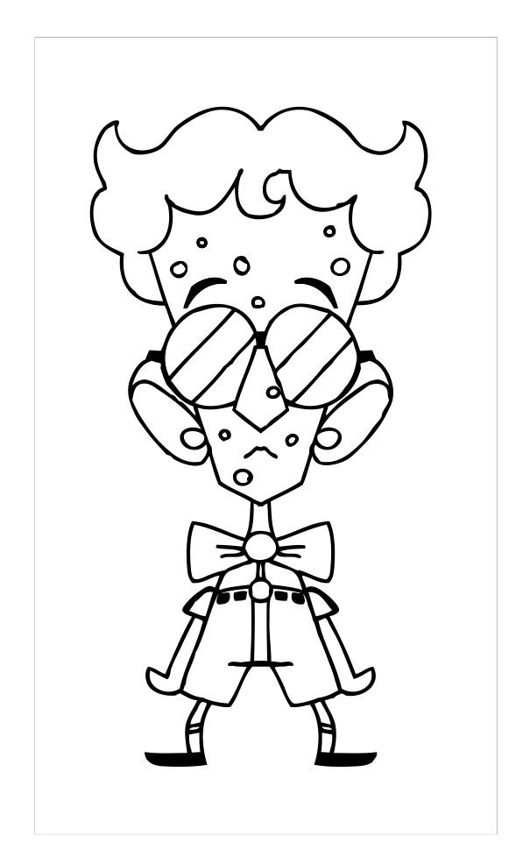

|  |  |
| --- | --- |
| **Description** | **Location** |
| Pizza Face | assets/characters/ |

9.5.4 Rad Tish

You are what you eat. That’s the case with Tish, she loves to eat veggies to help spring her athletic diet full force. She’s a tall slender girl with a radish shaped head. Her hair looks like the sprouts and leaves of a radish and her body’s slender shape looks like that of a leek. Due to her great track scores most people think she’s rad. Which of course gave her the name Rad Tish.

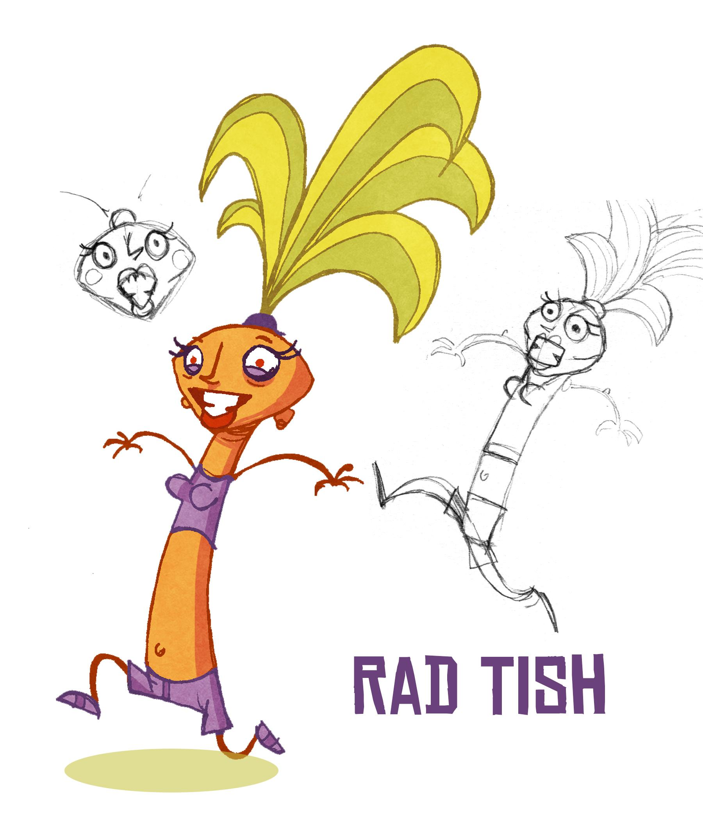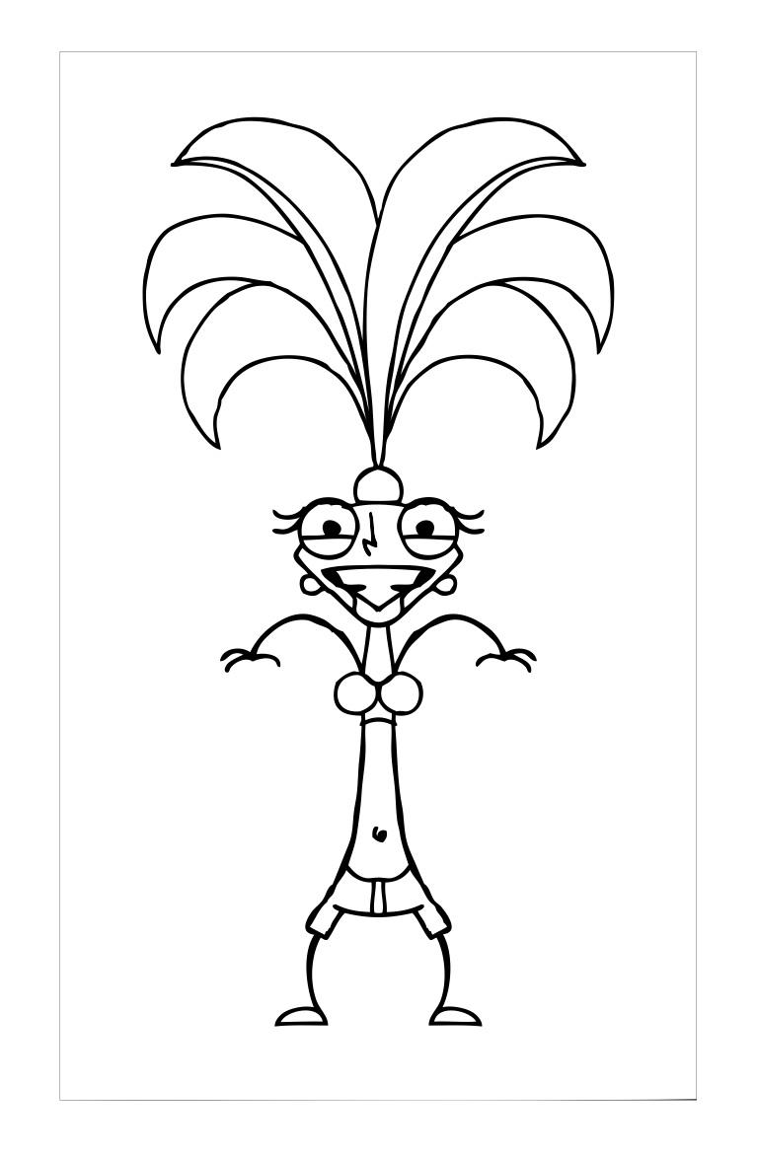

|  |  |
| --- | --- |
| **Description** | **Location** |
| Rad Tish | assets/characters/ |

9.5.5 Principal Deen

Principal Deen is the school’s principal and the one behind most of the food warfare. She’s been providing the students with sloppy, buttery foods to use in food fights. If you thought she was your average cooking show host- you were wrong. This foul mouthed goddess will stop at nothing to silence Snack. Since her body is so greasy and large she needs a mechanized flight pod to maneuver around. Which comes equipped with two butter cannons.

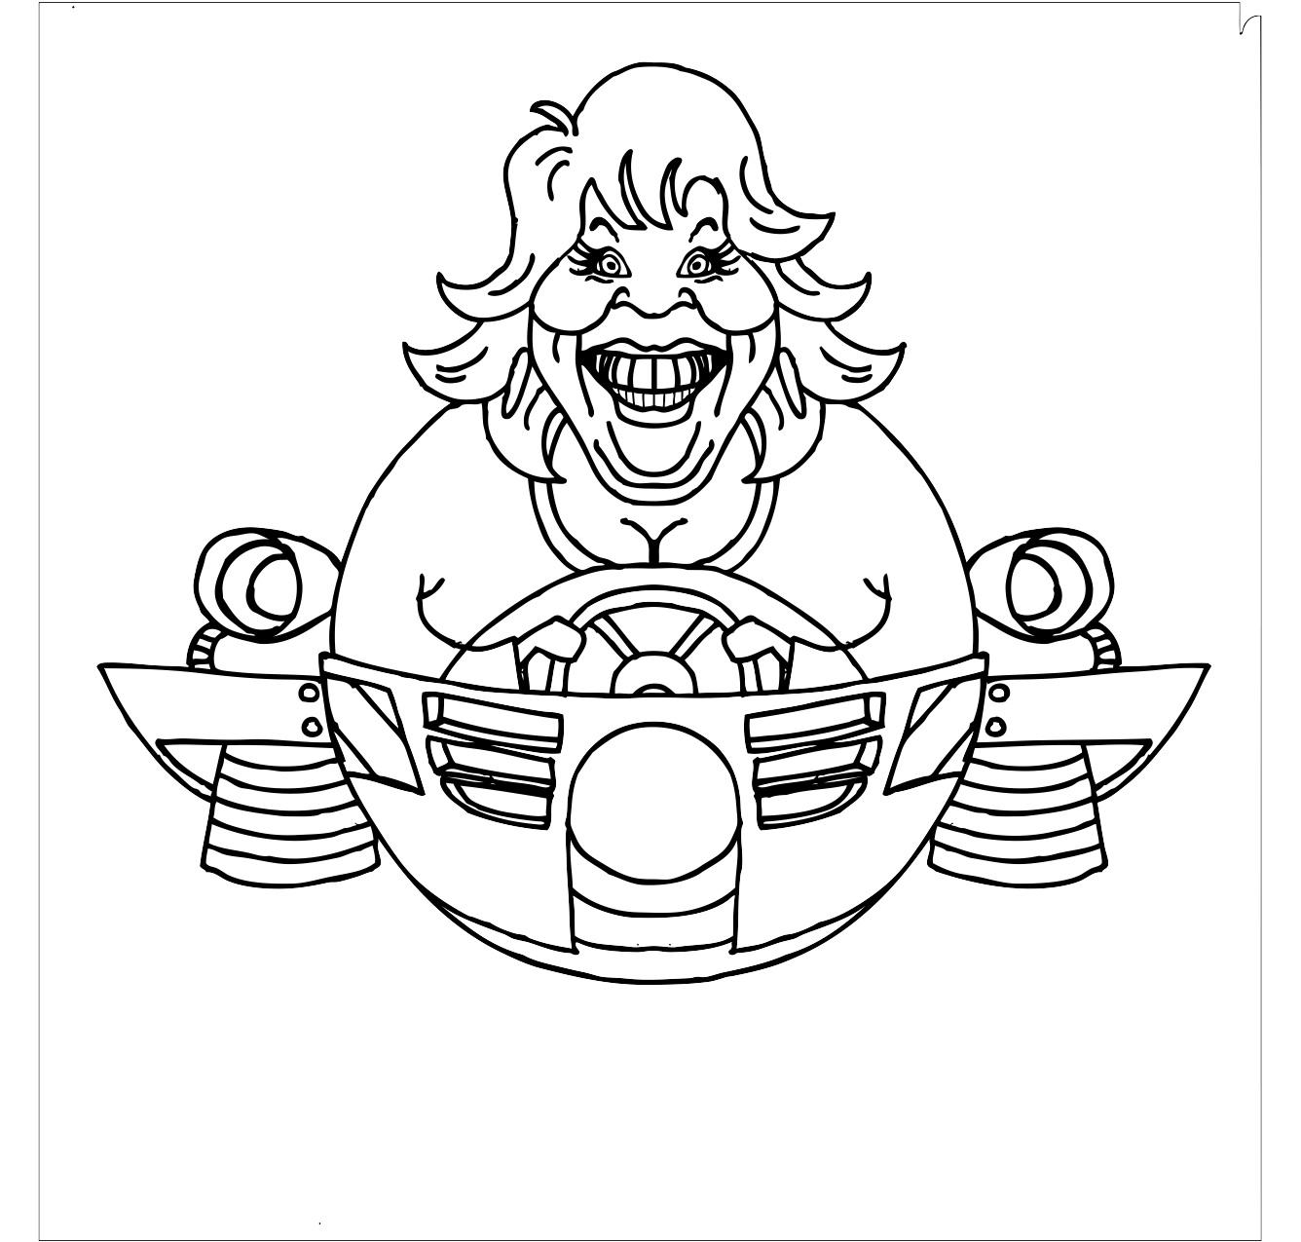

|  |  |
| --- | --- |
| **Description** | **Location** |
| Principal Deen | assets/characters/ |

**9.6 Items**

9.6.1 Food

Food will be split into three categories (small, medium and large) and will do damage accordingly. Enemies will have, essentially, three HP. Small foods will deliver 1 hit point, medium foods will deliver 2 hit points, and large foods will deliver 3 hit points.

9.6.1.1 Small Size

|  |  |
| --- | --- |
| **Name** | **Location** |
| Carrots  Broccoli  Apple  Orange  Kiwi  Grapes  Olives  French Fries  Meatballs  Chicken Wings  Rice  Cupcakes  Peas  Eggs  Salad | assets/items/food/small |

9.6.1.2 Medium Size

|  |  |
| --- | --- |
| **Description** | **Location** |
| Potatoes  Hot Dogs  Chicken Patty  Mexican Pizza  Cheese Pizza  Taco  Burrito  Pancakes  Waffles  Scrambled Eggs  Spaghetti | assets/items/food/medium |

9.6.1.3 Large Size

|  |  |
| --- | --- |
| **Description** | **Location** |
| Steak  Hamburger  Cheeseburger  Deluxe Pizza  Watermelon  Cantelope  Pan Pizza | assets/items/food/large |

9.6.2 Power-Ups

9.6.2.1 Energy Drink

The energy drink power-up allows the player to move faster as well as throw food faster during a times duration of 5 seconds.

9.6.2.2 Pea Gun

The pea gun will automatically shoot peas at a fast rate for a timed duration of 5 seconds

9.6.2.3 Popsicle

The popsicle power-up will freeze enemies for 5 seconds

|  |  |
| --- | --- |
| **Description** | **Location** |
| Energy Drink  Pea Gun  Popsicle | assets/items/powerups/ |